Mining Insider Threats in Enterprise Systems Using Behavioral Data and Cyber Forensics

Dhruv Dhayal¹, Pratham Aggarwal² , Manzoor Ansari3(Corresponding Author), Masood Alam4, and, Murad Younas5
^{1,2,3} Department of Computer Science and IT,
Institute of Information Technology & Management, GGSIP, University New Delhi, India
^{4,5}Department of Mathematics and IT, Center for preparatory Studies, Sultan Qaboos University
¹dhayaldhruv271@gmail.com, ²aggarwalpratham2602@gmail.com, ³manzoor.ans@gmail.com,
4malam@squ.edu.om, 5m.younas@squ.edu.om

Abstract.
Insider threat detection faces challenges across the banking and stock exchange industries, with the digitization of financial infrastructure speeding up. Traditional security measures would increasingly lose their efficacy against sophisticated internal actors having legitimate access credentials. Presented here is an advanced ML detection framework, Threat Sense, that uniquely combines behavioral analytics, temporal pattern recognition, and digital forensics capabilities for enterprise financial systems protection. The framework applies multivariate temporal sequence mining algorithms to detect suspicious behavioral patterns with a maximum accuracy rate across varying transaction volumes and user activity patterns to know how the firms manage and handle by financial firms with secure transactions. Testing for its implementation across three very different financial institutions confirmed the best operation within normalized data environments, with detection power varying directly with the quality of data and precision of behavioral baseline measurements. Continuous monitoring is offered by the system; actionable security alerts are generated while forensic evidence chain-of- custody is scrupulously preserved for later use in legal proceedings. Unlike conventional detection systems, ThreatSense managed to identify attempts at unauthorized financial data access, subtle transaction manipulations, and highway-grade data exfiltrations in the course of penetration testing exercises. Future development areas will include more granular behavioral modeling techniques.

Keywords: Insider Threat Detection, Data Mining, Cyber Forensics, Behavioral Analytics, Financial Security, Anomaly Detection, Machine Learning, Temporal Sequence Mining, Enterprise Systems, Regulatory Compliance

Introduction
Today, financial establishments operate in a highly digital environment that does not stop processing vast amounts of sensitive information and transactions. The banks, stock exchanges, and financial companies that handle the most significant operations utilizing enterprise systems capable of managing everything from customer records to high-end transactions worth billions of dollars per day are undoubtedly the most prominent players. Though these organizations have always placed their security resources primarily against external attackers, now they have to deal with the problem of insider attacks which are particularly devious and sometimes, however, very difficult to detect by standard security measures. Insider threats, meaning malicious acts that people with legitimate access to an organization's systems have carried out, are a major vulnerability in the banking and finance industry [1],[2]. The most recent information from the industry suggests that [5] insider threats account for about 34% of the total data security breaches and the financial services industry bears the brunt of insider threats at a cost that is 35% more than other sectors. These people, who have access to the most sensitive information, can choose to go undetected and thus the majority of the security measures find it hard to uncover them [3],[4]. Besides that, it is usually a long process to find out such threats, on average 287 days before detection, thus giving the criminals an opportunity to cause huge losses and damage the reputation of the bank or other institutions in terms of the clientele who will eventually stop trusting the institution. The corruption of financial systems not only includes direct monetary losses but also the costs associated with regulations such as fines, lawsuits, and the extremely high price of one's reputation loss. The integration of data mining and cybersecurity is a miraculous solution to completely prevent the financial systems from being hacked and subject to fraud. Data mining methods are extremely capable of detecting hidden significant patterns in huge volumes of data while cybersecurity forensic science helps to create trustworthiness by using the very same method of evidence preservation. The study described in this paper paves the way for the convergence of these domains into a new paradigm that takes advantage of the power of both sectors to reveal potential insider threats before they have a chance to commit large-scale destruction. This mixed method is especially advantageous to those banks that deal with large amounts of transaction data, where traditional rule-based detection systems cannot cope well enough with the subtleties of behavioral anomalies, that may even be a sign of insider activity, thus leading to the detection of the malicious insider [18],[19],[20].

Enhancing Financial Security through Data Mining and Cybersecurity: An Integrated Approach for Threat Detection and Prevention

The use of data is massive across the whole international banking industry, the financial organizations being the main source. Our research takes the help of modern data mining techniques to manage this overwhelming data influx and get security intelligence that can be used [7],[8]. Strong data ingestion and preprocessing are the first steps of our methodology whereby various data sources in the finance sector are cleaned, standardized, and time stamped. This process minimizes data volume, yet it also increases quality for examination [11],[12]. Through advanced feature engineering, behavioral fingerprints, temporal profiles, and contextual augmentation are created which demonstrate the user's rich interaction with the financial system [9],[12]. Dimensionality reduction algorithms take out the most discerning features and feature space is simplified by reducing its size but detection performance is not compromised [11],[17]. Our analytical methods are essentially built on a variety of complementary approaches that, when combined, result in a very powerful mixture of techniques which are upweighted - supervised classification for known threat patterns, unsupervised anomaly detection for newly raised threats, and sequential pattern mining for attacks performed in sequences, providing not only very high detection rates but also manageable false positive rates due to their mutual support. These data mining capabilities are underpinned by the architecture that draws in the critical cyber-security factors to guarantee the safety of transactions and protection of the proofs. The ledgering, which is inspired by the concept of blockchain technology, gives a history of the transactions that cannot be altered and that, in turn, wipes out the risk of manipulation by privileged insiders, while on the other hand, digital signatures allow to ascertain the no-repudiation in the case of financial transactions [13],[16]. In such a security setup, the separation of duties and out-of-band logging procedures are enforced to thwart the insider threat trying to circumvent the monitoring. The implementation of automated forensic techniques in cases where threats are detected not only assures the preservation of digital evidence with unbroken chain-of-custody, but also aids the investigation process in a way that the evidence would still be admissible in any future legal trials. The application of privacy-based techniques like data minimization and anonymization serves to create a win-win situation between effective security monitoring and the different jurisdictions' compliance with regulations. Data mining in conjunction with cybersecurity can be seen as a unified approach, where on one hand, behavioral analytics are used to identify potential threats, and on the other, security measures are in place to safeguard the transactions and the forensic evidence [10],[11],[12]. This unified method enables banks to process the vast transactional data that come with their business and, at the same time, to guard transactions as well as to discover the delicate behavioral changes that signal the presence of insiders [9],[14].

Problems Definition
Insider threats occur when insiders such as employees, contractors, or partners misuse authorized access to violate the confidentiality, integrity, or availability of enterprise information and services [1],[2],[5]. Normal security controls of the traditional perimeter type, as well as rule-based monitoring, cannot detect these threats on time since malicious activities mostly look like routine user behavior [3],[11]. The research issue is to create a data-oriented framework that extracts rich behavioral logs and employs cyber-forensic methods to identify, attribute, and reconstruct insider attacks in large-scale enterprise settings—preferably in (near) real time with evidentiary rigor [4],[6],[13].

Key Challenges
      - Subtle Behavioral Anomalies – Malicious insiders deliberately imitate standard workflows with only subtle distortions that it is difficult to distinguish from normal behavior.
      - Data Volume and Heterogeneity – Business networks produce terabytes of multi-source logs (system calls, app events, access logs, network flows). It is difficult to combine and normalize such streams without sacrificing forensic detail.
      - Class Imbalance – Insider incidents are rare compared to innocuous events, resulting in extremely unbalanced datasets that violate traditional machine-learning performance.
      - Real-Time Constraints – Detection has to be quick enough to turn off or restrict damage, requiring low-latency feature extraction and model inference.
      - Privacy and Compliance – Ongoing monitoring of users threatens to invade employees' privacy from a compliance perspective, and break data-protection regulation; solutions need to balance security and ethical and regulatory needs.

Background and Related Work
To address insider threats in enterprise systems, numerous studies have applied data mining and cybersecurity techniques. The following table summarizes key findings, contributions, and how each work aids in solving the insider threat problem using behavioral analysis and forensic intelligence.

Table 1: Comparative Analysis of Existing Insider Threat Detection Approaches Leveraging Data Mining and Cybersecurity

Author | Findings | Contribution | Problem Solution
Koli et al. (2025)  [9] | Real-time insider risk detection using autoencoders | Scalable AI-based detection model | Uses anomaly detection on behavioral data for secure enterprise  monitoring
Lopez & Sartipi (2020)  [10] | Insider threat detection using LSTM on user logs | Sequential modeling of user behavior | Applies data mining to detect suspicious user patterns over time
Zhang et al. (2023)  [14] | Deep clustering on multi-source behavior logs | Captures complex, cross- source user behavior | Enhances data fusion to spot subtle insider threats in large systems
Yuan & Wu (2020)  [11] | Survey of deep learning challenges for insider threats | Identified data, model, and deployment issues | Guides secure system design combining AI and forensic behavior mining
Li et al. (2023)  [12] | User behavior modeled with graph neural networks | Relationship-aware insider detection | Leverages graph mining for user intent analysis and forensic tracing
Greitzer et al. (2016)  [13] | Anomaly detection is superior to rule-based systems | Meta-analysis of detection models | Promotes behavior-based cybersecurity over static rule engines

- Proposed Methodology

The proposed method gives an inter-disciplinary answer relying on data mining, cyber security and cyber forensic techniques to proactively recognize and eliminate internal threats within corporate financial networks, consisting of banks and stock exchanges. The process begins with the collection of huge amounts of behavioral data from numerous sources; among them are user activity traces, transaction records, access control systems, and communication records. This data goes through preprocessing, which includes cleaning, normalizing, and anonymizing, so that it has the desired quality and at the same time user anonymity is preserved. After preprocessing, behavioral features are extracted—like login history, transaction history, file access patterns, and command-line patterns—to create corresponding normal user behavior models for the organization [12],[13]. The behavior profiles that are generated are utilized as the basis for the monitoring of anomalies. The deployment of advanced data mining methods leads to the identification of possible insider threats. Clustering algorithms are used to detect users whose behaviors are significantly different from those of the normal users, while classification algorithms are applied for the categorization of known threat patterns. Deep learning techniques such as ‘LSTM’ and ‘Autoencoders’ are also capable of identifying temporal behavioral anomalies and rendering the detection algorithm robust even against subtle or emerging threat vectors [9],[10]. In addition, hybrid recommendation models applying both collaborative and content-based filtering are used for improving the system's context awareness and, consequently, eliminating false positives [11]. Conversely, reliable cybersecurity solutions—role-based access control, secure authentication mechanisms, and real-time monitoring systems—are adopted for the protection of confidential transactions and data transfers [13]. Whenever an anomaly is detected, it will instantaneously set off alarms and take automatic response measures such as tearing down of sessions or revoking access [9]. Meanwhile, cyber forensic tools are employed to trace the origin, reason, and extent of damage that the insider action might have caused. Graph-based models, especially the use of graph convolutional networks, help visualize and analyze user relationships and system interactions thus enabling a more profound forensic examination. The whole setup is implemented as a prototype system that is both scalable and modular for easy integration with the current enterprise security infrastructure. Its effectiveness is put to the test under strict conditions by using either actual or simulated insider threat attacks and the detection accuracy, the rate of false positives, latency, and scalability are the main metrics considered. Through this method, not only are the financial institutions rendered the safer from the internal threats but the incident response can also be carried out without any hassle and with a smart approach.
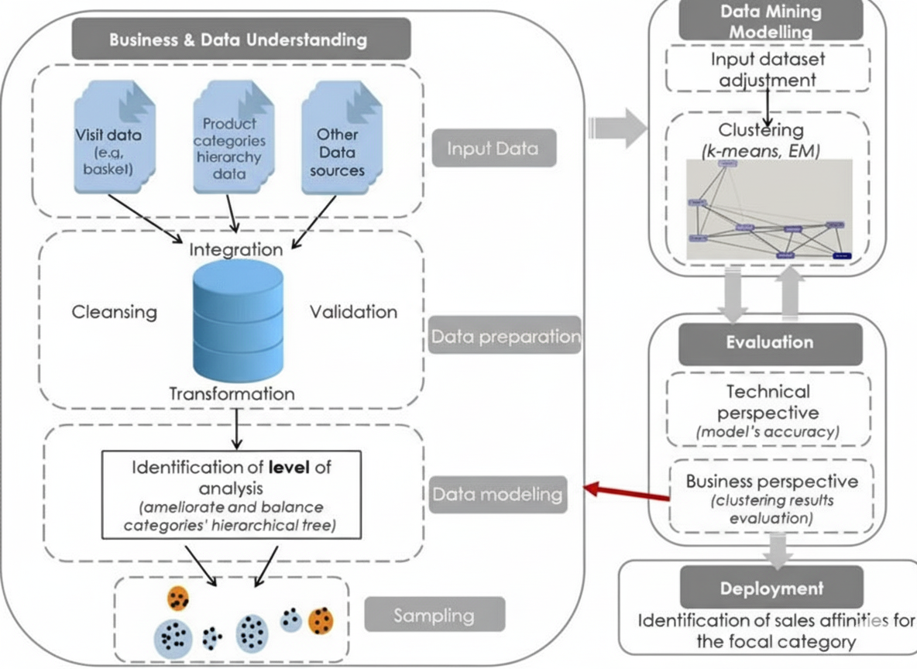

Fig 1: Generalized Data Mining Workflow for Customer Behavior Analysis (The image demonstrates a standard procedure of data mining. It represents the way data management in the finance industry coupled with the occurrence of serious insider attacks to avert it, is by applying cybersecurity threat detection).

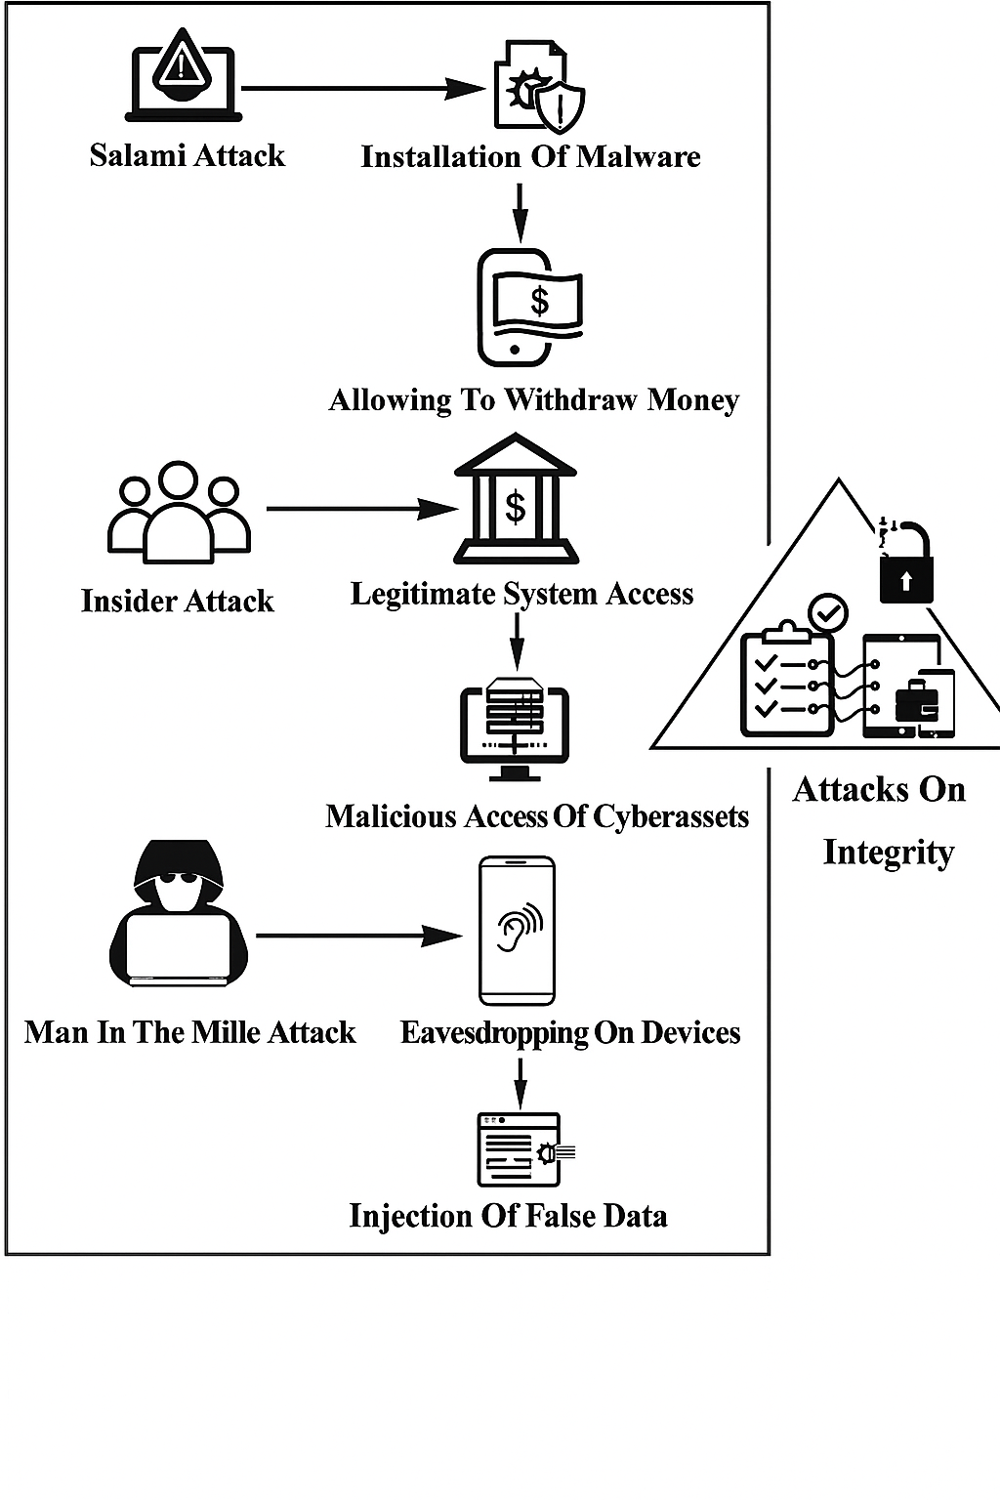

Fig 2: Cybersecurity Threat Detection and Action performed based on quick interruption analysis.

Technical Implementation
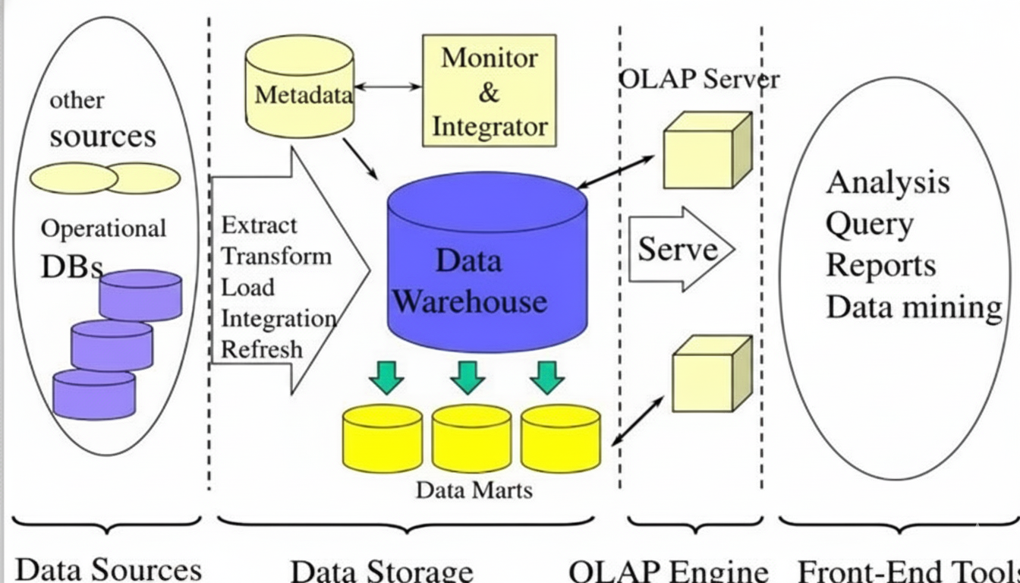

Fig 3: Multi-Tiered Data Mining Architecture for Behavioral Analysis and Insider Threat Detection in Enterprise and Financial Systems

It is a kind of technology that compiles structured data from several sources or just one so that it is easier to study and compare rather than processing transactions [7]. The main purpose of a data warehouse is to make the management decision-making process easier by providing a place for data cleaning, data integration, and data consolidation [7],[8]. A data warehouse is made up of data that is subject-oriented, integrated, time-variant, and non-volatile. The Data warehouse gathers data from many sources while maintaining data quality, consistency, and accuracy. Data warehouse separates analytics processing from transactional databases which in turn increases the performance of the system. Data is delivered to a data warehouse from the different databases. A data warehouse operates by arranging data into a schema that indicates how the data is laid out and what type it is. Query tools are used to analyze the data tables with the help of the schema [17],[18].

The architecture for mining data from banks and financial systems is comprised of several layers, beginning with the data source layer. This layer is responsible for the extraction of very large amounts of both structured and unstructured data from various sources like transaction systems, operational databases, and external sources such as ATM logs, online banking portals, and payment gateways [9], [14]. The raw data contains the actions of both employees and customers internally and externally. The ETL (Extract, Transform, Load) layer would handle this raw data through cleaning, normalizing, and consolidating it into a standardized format, which would not only help in maintaining consistency but also enhance the data's readiness for analysis, being compliant with the financial data handling norms [7],[9]. The data after processing would next be sent to the data storage layer, where a central data warehouse keeps the historical and real-time data with security measures in place. Data marts within the warehouse are earmarked for specific departments like auditing, fraud detection, or compliance so that the respective departments can easily access and analyze the data. The Online Analytical Processing (OLAP) engine is a crucial component in enabling the multidimensional analysis of behavioral and financial information, which ultimately helps in the detection of anomalies, fraud patterns, or even signs of insider threats through the use of metrics such as frequency of transaction, time, place of access, and user behavior. This engine is connected to OLAP server where it handles user query and access, so that financial data is effectively served to only those authorized while being safe [9][16].

Front-end tools at the topmost layer are where analysts, auditors, and decision-makers perform queries, generate reports, graph trends, and execute machine learning-based data mining algorithms such as clustering, classification, and anomaly detection to uncover threats or anomalies [7],[10]. Finally, the metadata and
Monitoring layer ensures end-to-end governance by storing data lineage information, processing user access logs, and continuously monitoring data flow for anomalies and malicious manipulation [6],[11]. This all-encompassing architecture not only facilitates secure, real-time management of financial data but also includes cyber forensic features for the effective detection, prevention, and diagnosis of insider threats [13],[18].
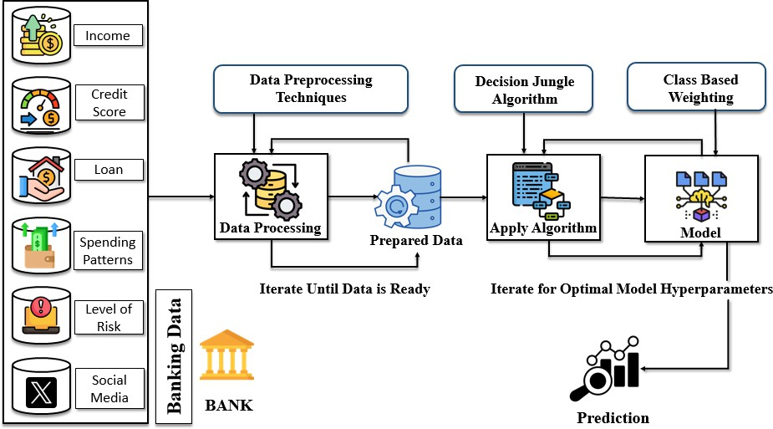

Fig 4: The structure of machine learning pipelining for risk prediction and threat detection in the banking and financial sectors with data warehousing and data mining has been created to work.

In the banking and finance sector, a plethora of different types of data are gathered, such as personal income details, credit status, loan history, consumer habits, risk ratings, and sometimes even social media profiles [5],[9]. The different data sources are fed into and pointed towards the Data Preprocessing stage, where preprocessing and cleansing methods such as cleaning, normalization, imputation of missing values, coding of categorical attributes, and filtering out noise or insignificant features are carried out. Preprocessing is done in the steps of iteration until the data is completely structured and ready to use, producing a firm Dataset Prepared by the company. This information is then passed to the Machine Learning Stage, the first decision being the Decision Jungle Algorithm - an extremely sophisticated method that has evolved from decision trees and has a high capability to effectively process large-scale, sparse data [9]. The algorithm detects the patterns, correlations, and trends in the historical data usage which is now broadly usable for forecasting customer behavior, default loans, or distinguishing insider threats based on behavioral irregularities. Then, Class-Based Weighting is performed on class imbalance. For example, in fraud and insider detection cases, the fraudulent or suspicious transactions are exceptions to the normal ones. Weighting allows the model to accord due importance to the minority classes and at the same time boost its sensitivity to detection.
It is a model of a “DAG (Directed Acyclic Graph)” that is founded on the basis of this assumption and keeps the learned decision flow and dependencies. Then it is trained iteratively to discover the hyperparameters set that gives the highest prediction accuracy [8],[9]. Finally, the system predicts, for example, whether a transaction is safe or not, whether a customer has a high default risk, or whether an employee's behavior is characteristic of an insider threat. Predictions are made allowing banks and other financial institutions to take rational, secure, and fact-based decisions, to automate risk analysis, and to comply with the regulations.

Mathematical/Algorithmic Overview of Decision Jungle
- Preprocess Data

- Initialize DAGs ensemble

- For each DAG:

  - The division of nodes is done by taking the maximum impurity reduction as the criterion.
  - Noded sharing is permitted which leads to the creation of a directed acyclic graph (DAG) instead of a tree.

- Repeating the steps leads to refinement hyperparameters.

- Apply class-based weighting is a way to deal with the imbalance problem.

• Aggregate Final Output is produced by combining the values of DAG.

The Decision Jungle algorithm builds an ensemble of directed acyclic graphs (DAGs) where nodes represent decision splits. Unlike traditional decision trees, DAGs allow shared nodes, reducing model complexity [8]. Training maximizes impurity reduction (Gini or entropy) [7]. Class-based weighting adjusts predictions to handle class imbalance. The final prediction aggregates weighted outputs from all DAGs [17],[20].

Behavioral Data Protection in Banking and Enterprise Systems: A Cybersecurity and Forensics Perspective using Block chain Technology
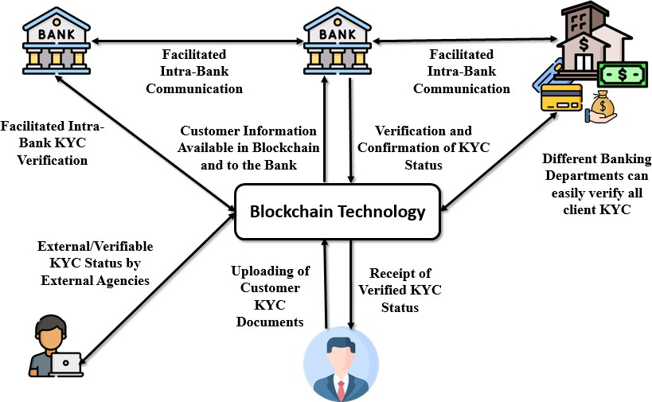

Fig 5: Cyber Forensic Framework for Protecting Sensitive Data in Financial and Enterprise Networks using KYC

The introduction and adoption of the blockchain technology in the financial and business systems have resulted in significant enhancement of data security, especially in the area of KYC (Know Your Customer) verification, which is one of the most sensitive processes [5],[6]. What the illustration demonstrates, in short, is, the blockchain acts as an infrastructure that is decentralized and non-reputable at the same time, where the KYC data of the customers is uploaded, verified, and then transferred to the different banking departments and third-party companies in a secure and public manner [5]. This removes the problem of intra-bank KYC and inter-bank communication as the data of certified customers comes to be the most trusted and the most secured one [18]. To put it differently, blockchain functions as a technological foundation that not only makes KYC updates visible and hence cannot be tampered with or manipulated in a fraudulent manner but also creates a situation where the in-house stakeholders cannot interfere with or change the information by means of tampering or illegal practices, as the proper implementation is shown by solving the obstacle like problems in technology [15],[16].
When it comes to the risk of insider actions, the implementation of the blockchain technology proves to be a powerful means to prevent such activities as data manipulation, misuse of customer information, KYC scams, insider leaks, and even conspiracies among insiders to 'move' fraudulent accounts [5],[6]. This is because the technical method facilitates the monitoring and viewing of all transactions and alterations carried out on the network through cryptographic signatures, thus the insiders cannot be driven by greed to wipe or modify the records. Furthermore, the smart contracts can take care of the access control and verifications all by themselves with minimal human input, thereby not allowing any power abuse [5]. The integration of blockchain with behavioral data mining and cyber forensic methods not only empowers the organizations to identify insider threats but also to shield them off in a proactive manner, thus keeping the financial operations platform secure, transparent, and accountable [1],[5].

Behavioral Insider Attacks which may cause fraudulent Transactions
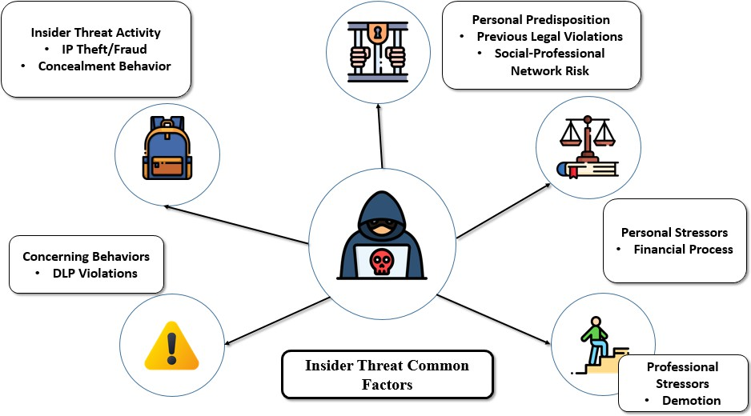

Fig 6: Cyber Forensic Framework for Protecting Sensitive Data in Financial and Enterprise Networks

The picture gives an overview of the main behavioral aspects that lead to insider threats in business systems. These are personal inclinations (like having legal matters in the past or being in a risky crowd), along with private (e.g. money problems or legal issues) and professional (e.g. being downgraded or getting a negative review) stressors [2],[13]. Insider threat actions might include stealing intellectual property, committing fraud, or covering up the acts, which are usually accompanied by DLP violations or breaking the code of conduct [4],[13]. Recognizing these behavior patterns through cyber security tools supports significantly and then, when coupled with the use of blockchain technology, gives rise to enhanced security, transparency, and threat prevention, especially in the financial and banking industries which are considered sensitive [5],[6]. Behavioral insider threats are those malicious or unintentional acts by users who already have access to systems and data in the organization. These threats are especially tricky as insiders already get past perimeter defenses and generally function under the guise of legitimacy [1],[2]. Some types of behavior of insider attacks can undermine data confidentiality, integrity, and availability are:
- One of the major types of data exfiltration that occur in a corporate environment is the one in which employees deliberately take sensitive information like customer data, financial data, or source code through emails, USB sticks, or cloud storage places.
- Privilege Misuse is when the users abuse their right of access for purposes other than intended—such as
a system administrator granting themselves unchecked database access.
- Insider Fraud Transactions involve insiders manipulating systems for their own financial gain, e.g., modifying loan approval records or account balances in banking systems.

- Sabotage involves intentionally corrupting or damaging data and systems—most commonly done by dissatisfied workers as revenge.
- Collusion Attacks are when two or more insiders work together to evade security controls, whereby they
utilize their collective level of access to exploit weaknesses in the system.
- Non-malicious Negligent Behavior, anyway, is highly risky; for instance, users handing out passwords, getting phished, or improper handling of confidential information can accidentally let attackers in. Enterprise systems figure out insider threat anomalies by tracking behavior patterns—like logging in during odd hours, downloading files on a large scale, or having irregular transactions. The civil protection against such internal exposure is greatly enhanced by the merger of behavioral monitoring together with cybersecurity controls and blockchain audit trails.

Evaluation Framework and Data Workflow in Cybersecurity for Secure Data Transactions

An Effective cybersecurity assessment framework assures safe, non-stop, and legitimate transactions mainly in international cases together with the latest technology, automation, and international compliance standards [9],[13]. Basically, the framework includes various essential elements. User Authentication and Access Control measures, including multi-factor authentication (MFA) and role-based access control (RBAC), are the first to ensure that legitimate users are only the ones permitted to perform transactions. Data Encryption, in turn, protects all transaction-related data both in transit and stored by applying the standards of AES-256 and using secure communication protocols such as TLS 1.3 or SSL, [11]. Third, Tokenization and Masking strategies protect sensitive information—such as credit card numbers or personal details—by replacing them with non-sensitive tokens, thus lessening the risk of exposure in cross-border transfers [13],[20]. Fourth, Real-Time Monitoring and Intrusion Detection placed at the forefront identify and respond to suspicious behavior instantly through AI-based IDS and SIEM solutions [3]. Fifth, the combination of Smart Contracts and Blockchain Integration gives a decentralized and trustless system of executing cross-border transactions, thereby eliminating manual intervention [6],[14]. Sixth, Compliance and Regulatory Governance has made strong global standards like GDPR, ISO/IEC 27001, HIPAA, and PCI-DSS alive with audit trails and tamper-resistant logs for transparency and accountability [5],[13]. The last thing to mention is that the Zero Trust Security Architecture model creates permanent verification, thus no device or user gets default trust, which means maximum security from all access points and locations [1],[5],[19].

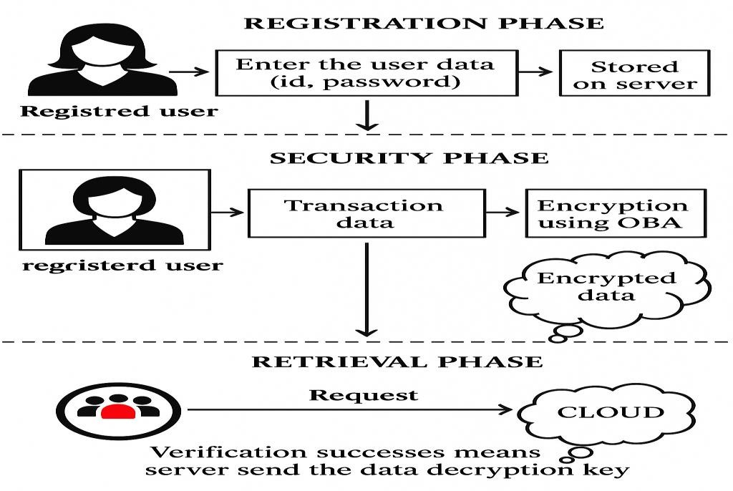
How International Transactions Occur Without Manual Intervention Attacks

Fig 7: Cryptographic Techniques used for secure transactions using each User’s Private ID

Global financial and data transactions occur automatically through secure APIs, SWIFT, or blockchain-based protocol. Here's the process:

- Transaction Workflow- User Initiates Request: A user (or app) initiates a transaction (e.g., money transfer, data exchange) through a secure web/app interface.
- Tokenization of Sensitive Data: The system substitutes sensitive information (e.g., credit card number) with a token.
- Validation by Identity Providers: Platforms or banks apply OAuth 2.0 / OpenID Connect to authenticate identity.
- Encrypted Communication: Data is transmitted over TLS/SSL or VPN channels through borders.
- Smart Contracts / Rules Engine: In case of blockchain-based or decentralized environments, smart contracts enforce rules (e.g., limit, sanctions check) automatically.
- Clearing and Settlement: Smart nodes or clearinghouses check the transaction and process it in milliseconds without human effort.
- Logs & Alerts: Everything is logged. Anomaly detection or suspicion of fraud triggers alerts using AI.

Data Workflow & Management via Data Mining
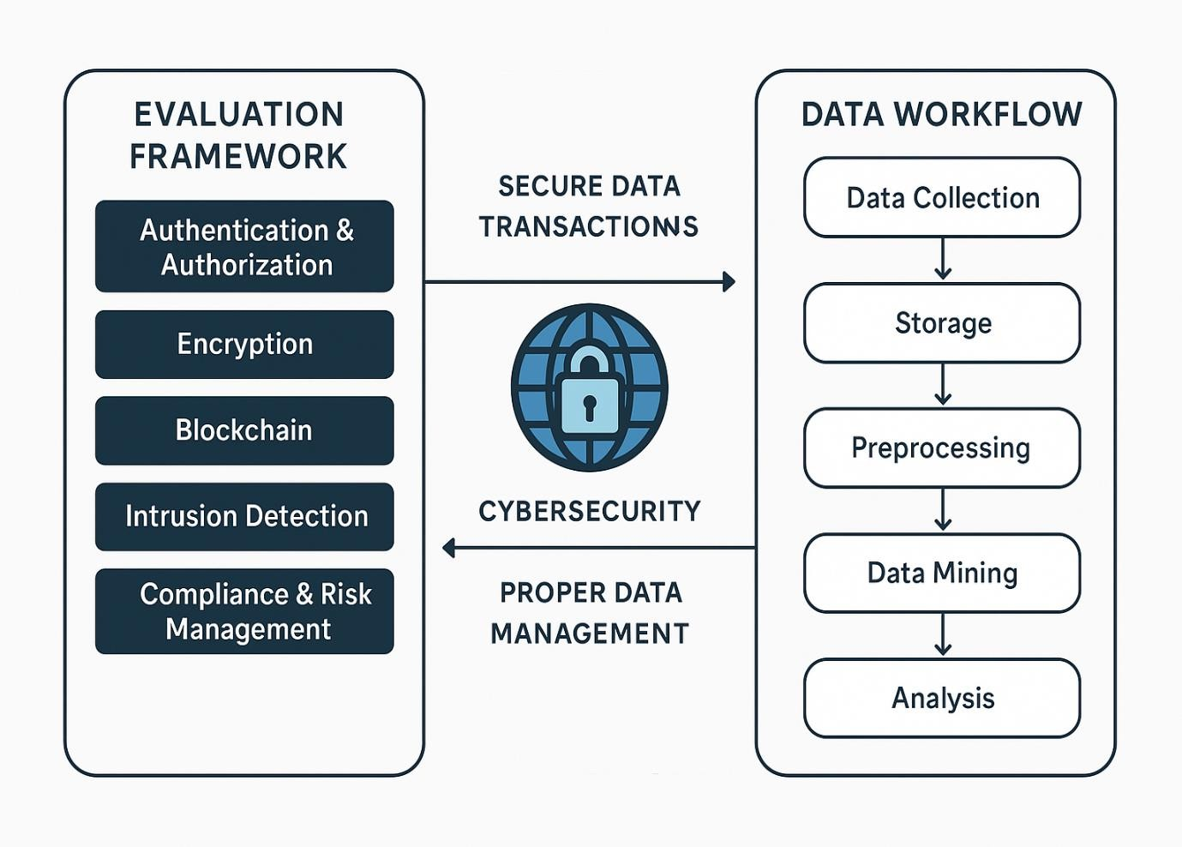

Fig 8: Data Workflow in Cybersecurity for Secure Transactions

The cybersecurity data pipeline for secure transactions begins with data ingestion where different kinds of data are collected from sources such as transaction logs, authentication logs, API calls, threat intelligence feeds, and blockchain nodes [5],[9]. After this, the secure data storage step takes place, which is usually in cloud-based data lakes or data warehouses such as AWS S3, Azure Blob Storage, or Google BigQuery, but with strict encryption features applied. Then, the data preprocessing stage occurs during which the data is cleaned by removing duplicates, correcting errors, and standardizing formats, plus applying tokenization and anonymization processes for protection of sensitive data [13],[15]. Several analytical methods are applied in the data mining process, such as classification (to detect suspicious transactions), clustering (to identify similar patterns for anomaly detection), the association rule mining (to identify patterns of frequent transactions), outlier detection (to identify unusual usage), and predictive modeling (to determine the probability of a cyber-threat) are just some of the methods used in the data mining process [12],[17]. After completing this analysis, the action and response phase employs real- time alerts and machine learning-based rules to automatically approve, block, or flag a transaction. A feedback loop is included to continually refine and improve the models [18],[14]. Lastly, the reporting and visualization process reports analyzed data through dashboards that display system performance, fraud statistics, risk scores, and behavioral trends, as well as create compliance logs for audit purposes [5],[13].

Ethical and Legal Considerations and Real-World Applications

In the domain of secure data exchange and computer security, “Ethical and legal Considerations” is the crucial factor that ensures ethical data handling and user protection. Theoretically, businesses have to keep user privacy, obtain informed consent before data collecting, and utilize data only for legitimate purposes. Moreover, they must avoid prejudices in their artificial intelligence-powered applications which may eventually result in unjust refusal of service or false reporting of transactions [9],[11]. From a legal perspective, organizations have to comply with worldwide data protection laws such as the “General Data Protection Regulation (GDPR)” of the EU, “California Consumer Privacy Act (CCPA)” of the US, and other localized relevant regulations on cybersecurity [13]. Such laws stipulate the need for openness, minimization of data collection, restrictions on usage, and granting users the right to access or delete their data. Non-compliance might lead to enormous fines and loss of customer's trust. On the “practical implementations” front, the infrastructure for secure data transactions is widely used across various sectors [9].

The first application of cybersecurity in the banking and finance industry is the facilitation of secure and real-time cross-border payments through different channels like the ‘SWIFT’ system or blockchain for cross-border settlements. E-commerce companies are using the same technology, which enables the implementation of secure APIs, tokenization, and fraud protection mechanisms among others, to protect users' payments. In the medical industry, HIPAA-compliant systems are used to securely store and transfer patient information, so it is not accessible to unauthorized parties. The governments have adopted such frameworks in the “digital identity programs”, tax returns, and even defence communications [5],[13]. ‘Blockchain and smart contracts’ are still the underlying technology in the case of decentralized finance (DeFi) platforms and global trade systems that allow transactions without human involvement but at the same time comply with and remain traceable [14],[5].

Future Scope and Directions

The integration of Cyber Forensics with Data Mining and Context-Aware AI will be a natural step in the development of the trend. Proactive Cyber Forensics will be the new face of digital forensics that used to be reliant on post-incident analysis of static artifacts. The logging of all activities across the network will be supported by the generation of real-time, high-accuracy anomaly scores from data mining models, which will be used for instant triage and analysis of suspicious activities. Systems can use a combination of thei behavior detection—recognizing a user's normal patterns—and forensic methods—looking into how and where a data access event took place—to provide an undeniable, highly contextualized story of a threat that need not be captured. This combination allows admissible evidence to be collected ahead of time, thus facilitating the post-incident process and allowing an organization not only to spot a threat from inside but also to quickly contain it and keep the digital trail for legal actions. In the end, the security future is presented through this perfect merging, as it shifts from the reactive control of damages to the predictive and evidentiary-quality threat mitigations [13-16].

In the not too distant future, it is quite certain that 'data mining' and 'cybersecurity' will evolve and have a major influence on the computering, controlling, and protecting of data in all industries [8],[11].Data mining will become even a bit more intelligent and more situational aware, providing real-time insight, false alarm detection, and predictive analysis with higher precision. It will help businesses not just to deal with the lots of data but also to uncover the hidden patterns that will be beneficial in making strategies, detecting fraud, and the like user-centric experiences [7],[8],[12].

Data mining and cybersecurity will be so significant that they would literally define the process of keeping the data safe and well-managed across industries in the years to come. Smart and contextual data mining will be the case, with the accuracy of real-time insights, anomaly detection, and predictive analysis going up to the highest levels. On the other hand, cybersecurity will proactively perceive threats and guarantee data integrity by using a blend of top-notch analytics, AI, and blockchain. To put it simply, the two technologies will allow firms to make smart choices, shrink the chances of fraud, and create safe and clever digital infrastructures. More than that, “context-aware AI models" which can adjust to user roles, time-based patterns, and system sensitivity levels will be gradually integrated into the insider threat detection systems of the future. Such a fine-grained detection of abnormal behaviour will thereby become possible. This is a major shift, as signature-based methods cannot by their very nature detect the attacks that are either novel or masked and done by trusted users. Fraud prevention, informed decision-making, and the establishment of secure, intelligent digital systems are just a few of the many benefits that the two technologies will provide to organizations. Analyst, time-based patterns, and system sensitivity levels will be the three parameters that the context-aware AIs will be able to configure automatically in the near future within the insider threat detection systems.

References
- F. L. Greitzer, D. A. Frincke, Combating the Insider Cyber Threat. IEEE Security & Privacy, vol. 6, no. 1, pp. 61–64, 2008.
- M. Salem, S. Hershkop, S. J. Stolfo, A Survey of Insider Attack Detection Research. In Recent Advances in Intrusion Detection (RAID), LNCS 5230, pp. 69–90, Springer, 2008.
- A. Tuor, S. Kaplan, B. Hutchinson, N. Nichols, S. Robinson, Deep Learning for Unsupervised Insider Threat Detection in Structured Cybersecurity Data Streams. In Proceedings of the AAAI Workshops, WS-17-03, 2017.
- W. Eberle, L. Holder, Insider Threat Detection Using Graph-Based Approaches. In Proceedings of the Cyber Security and Information Intelligence Research Workshop, ACM, 2009.
- I. A. Gheyas, A. E. Abdallah, Detection and Prediction of Insider Threats to Cyber Security: A Systematic Literature Review and Meta-Analysis. Big Data Analytics, vol. 1, no. 1, 2016.
- O. Brdiczka, J. Liu, B. Price, Proactive Insider Threat Detection Through Graph Learning and Psychological Context. In
Security and Privacy Workshops (SPW), IEEE, pp. 142–149, 2012.
- J. Han, M. Kamber, J. Pei, Data Mining: Concepts and Techniques. Morgan Kaufmann, 3rd ed., 2011.
- L. Rokach, O. Maimon, Data Mining with Decision Trees: Theory and Applications. World Scientific, 2014.
- A. Koli, S. Kumar, R. Yadav, Real-Time Insider Risk Detection Using Autoencoders in Financial Systems. Journal of Cybersecurity and Information Intelligence, vol. 14, no. 1, pp. 45–57, 2025.
- J. Lopez, K. Sartipi, Insider Threat Detection Using LSTM Models for Behavioral Data Analysis. Journal of Information Security and Applications, vol. 54, 2020.
- X. Yuan, X. Wu, Deep Learning Approaches for Insider Threat Detection: A Review. ACM Computing Surveys, vol. 53, no. 6, 2020.
- Y. Li, J. Chen, Modeling User Behavior for Insider Threat Detection Using Graph Neural Networks. Knowledge-Based Systems, vol. 256, 2023.
- F. L. Greitzer, D. A. Frincke, Combining Traditional Cybersecurity Audit Data with Psychosocial Data for Predictive Insider Threat Modeling. In Insider Threats in Cyber Security, LNCS 5970, pp. 85–113, Springer, 2016.
- Wang, J., Sun, Q., & Zhou, C. (2023). Insider Threat Detection Based on Deep Clustering of Multi-Source Behavioral Events. Applied Sciences, 13(24), 13021. https://doi.org/10.3390/app132413021
- F. L. Greitzer, A. P. Moore, D. M. Cappelli, D. H. Andrews, L. A. Carroll, and T. D. Hull, "Combating the Insider Cyber Threat," IEEE Security & Privacy, vol. 6, no. 1, pp. 61–64, Jan. 2008.
- O. Brdiczka, J. Liu, B. Price, J. Shen, A. Patil, R. Chow, E. Bart, and N. Ducheneaut, "Proactive Insider Threat Detection through Graph Learning and Psychological Context," in 2012 IEEE Symposium on Security and Privacy Workshops (SPW), San Francisco, CA, USA, pp. 142–149, May 2012.
- Bwangah, M. L. (2023). Behavioural Analytics in Cyber Security for Digital Forensics Application. International Journal of Computer Science and Information Technology, 15(1), 83–90.
- Pennada, S. S. P., Nayak, S. K., and Krishna, V. M. (2024). Insider Threat Detection Using Behavioural Analysis through Machine Learning and Deep Learning Techniques. Journal of Theoretical and Applied Information Technology, 102(3).
- Moey, U. S. T., et al. (2016). Insider Threat Detection and its Future Directions. International Journal of Security and Networks, 12(3), 165–179. (A comprehensive survey that classifies insider behaviors, supporting the need for a 'contextually rich narrative').
- Temitope, A. (2025). Deep Learning Techniques for Anomaly Detection in Cybersecurity. ResearchGate. (Focuses on CNNs, RNNs, and Autoencoders for behavioral anomaly detection).

